# Tech Weeks

# Day 2 Task Sheet

**Instructions**

1. The task sheet contains the necessary resources and the assignment for the day.
2. You are given **24hrs.** to submit the assignment on the Google Classroom.
3. You must upload the **.html files** and the **screenshots of the final output on browser** you have developed, on the Google Classroom.
4. These files are to be uploaded in .zip
5. You must implement the assignment in such a way that all the requirements specified are met.
6. Read the assignment problem statement thoroughly and then start implementing it.

## Learning:

1. Introduction to CSS - <https://youtu.be/Dziy1MEyOBw>
2. Inline CSS - <https://youtu.be/H1Iw9zdduKE>
3. Internal CSS - <https://youtu.be/IglSnU0AAV4>
4. External CSS - <https://youtu.be/saBkx-mIk0Y>
5. How to Debug CSS Code - <https://youtu.be/NRpoVhujB48>
6. The Anatomy of CSS Syntax - <https://youtu.be/XHkIU8Wom2Q>
7. CSS Selectors - <https://youtu.be/hvvzXwFAnKI>
8. CSS Classes vs Ids - <https://youtu.be/aMCCK0YrYoA>
9. How to create a nav bar in HTML AND CSS - <https://youtu.be/SdhmvnwOM2E>

## Assignment:

## This is a 2 part assignment first half is today.

## You have to create a navbar on top of the page (any type of nav-bar you prefer, sample is shown below)

## Put a background image as shown in the sample image below (you can use any image you like)

## Link for how to build nav bar is given above.

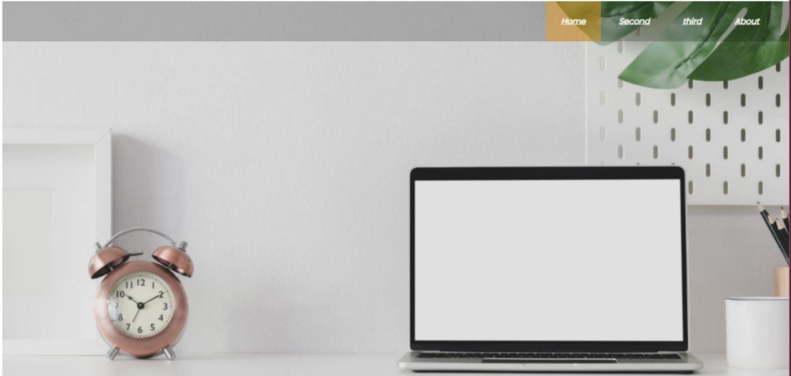

Index.html